**HTML <img> src Attribute**

Last Updated : 12 Jan, 2024

The **<img> src attribute** is used to specify the URL of the source image. It points to the location of the image file that the browser should display on the webpage.

**Syntax:**

<img src="URL">

**Attribute Values:**

It contains a single-value **URL** that specifies the link to the source image. There are two types of URL links which are listed below:

| **Attribute Values** | **Description** |
| --- | --- |
| **Absolute URL** | It points to another webpage. |
| **Relative URL** | It points to other files on the same web page. |

**Example:** This example illustrates the use of the image src attribute with an HTML document.

* html

|  |
| --- |
| <!DOCTYPE html>  <html>    <head>      <title>          img src Attribute      </title>  </head>    <body>      <h1>GeeksforGeeks</h1>      <h2>HTML <img> src Attribute</h2>      <img src=  "<https://media.geeksforgeeks.org/wp-content/uploads/20190506164011/logo3.png>"           alt="GeeksforGeeks logo">  </body>    </html> |

**Output:**

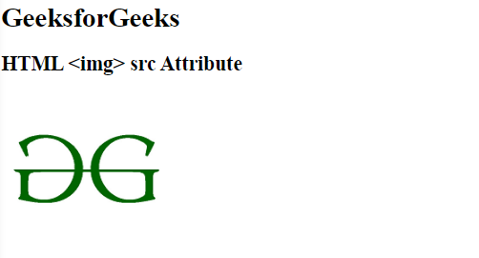

**Related DOM Property:**

[HTML DOM Image src Property](https://www.geeksforgeeks.org/html-dom-image-src-property/)

**Supported Browsers:**